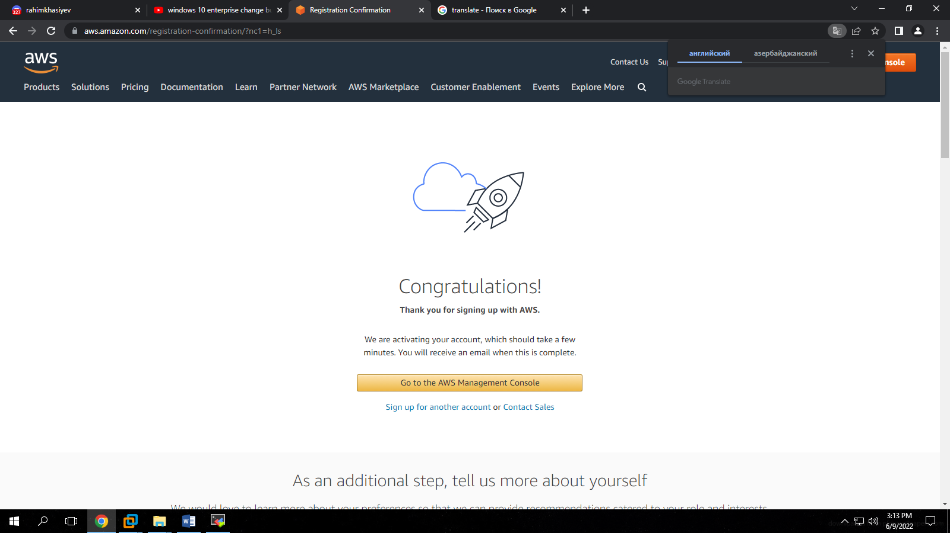

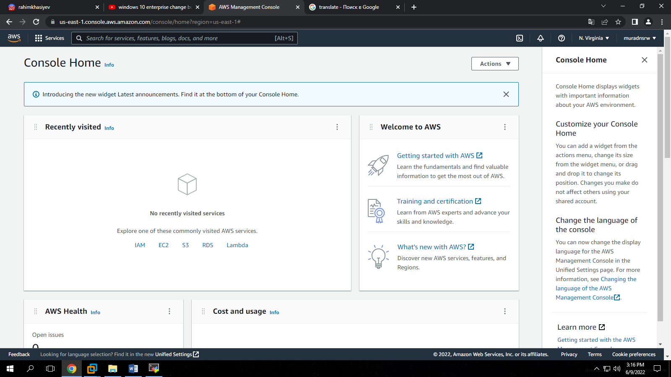

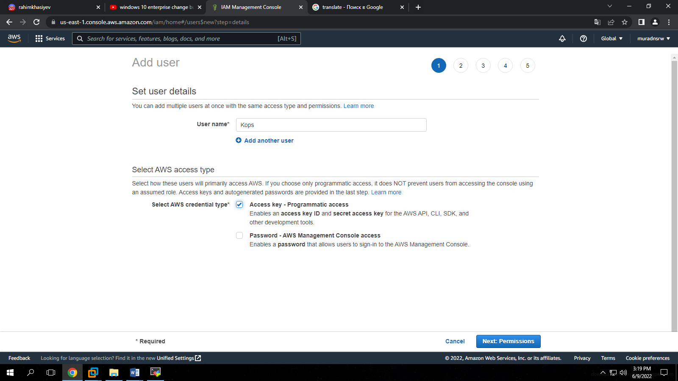

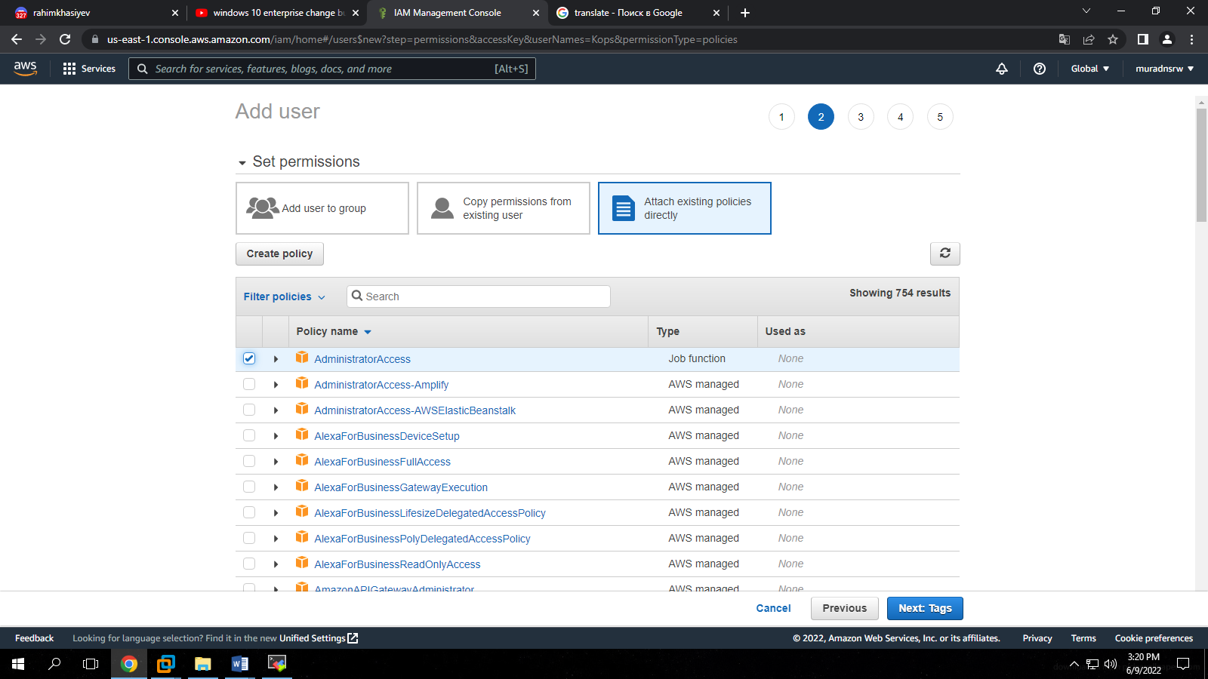

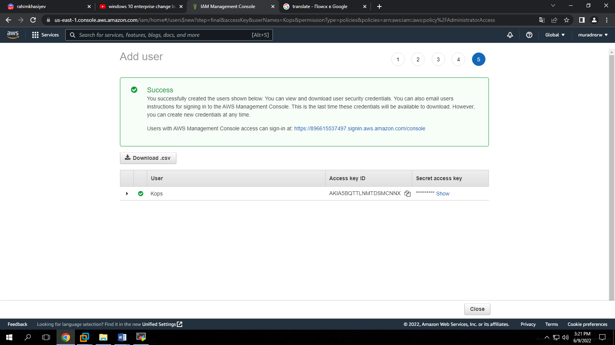

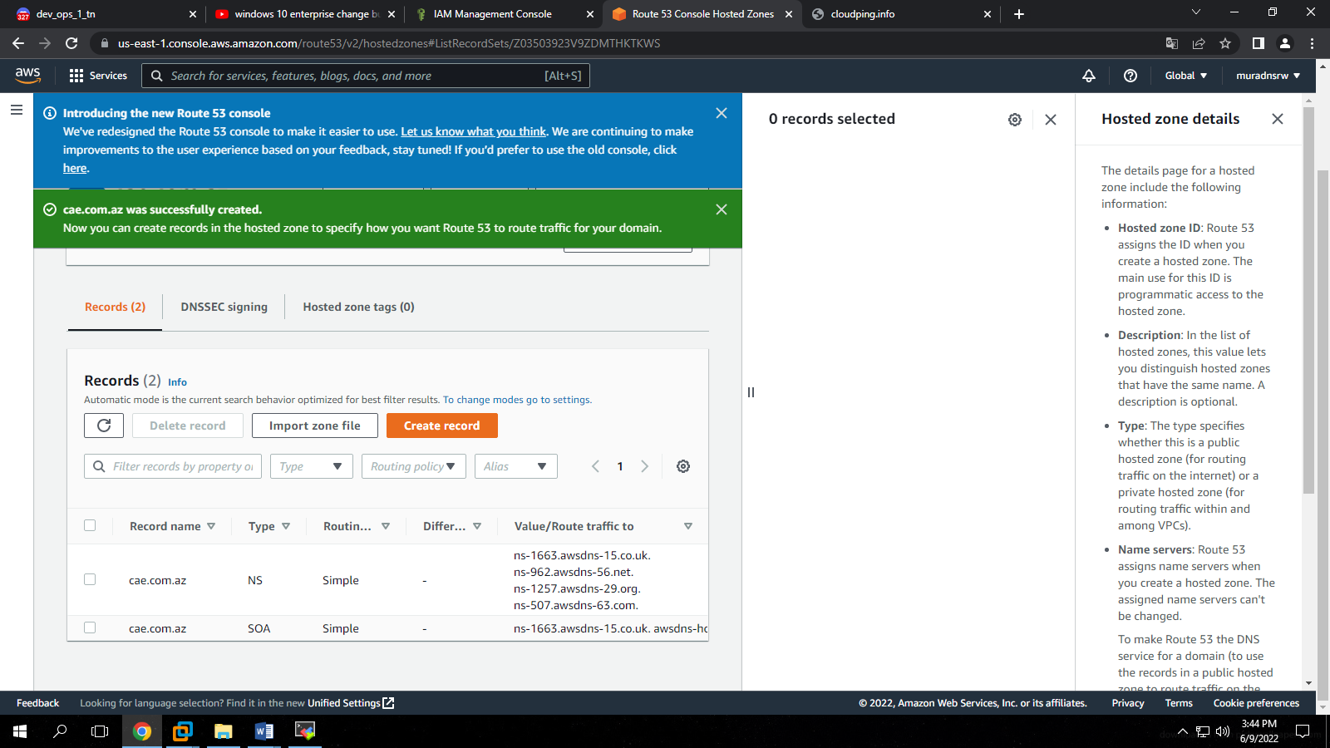

ns-1663.awsdns-15.co.uk.

ns-962.awsdns-56.net.

ns-1257.awsdns-29.org.

ns-507.awsdns-63.com.

ns-1663.awsdns-15.co.uk. awsdns-hostmaster.amazon.com. 1 7200 900 1209600 86400